

|  |
| --- |
| *BS Cyber Security Department AU* |

|  |  |
| --- | --- |
| **Registration ID** | **233026** |
| **Submitted By** | **Muhammad Sohaib Rafiq** |
| **Submitted To** | **Iram Fatima Hashmi** |
| **Date of Submission** | **12/02/2024** |
| **Lab NO.** | **1** |
| **Subject** | **OS LAB** |

Step 1: installing the snort:

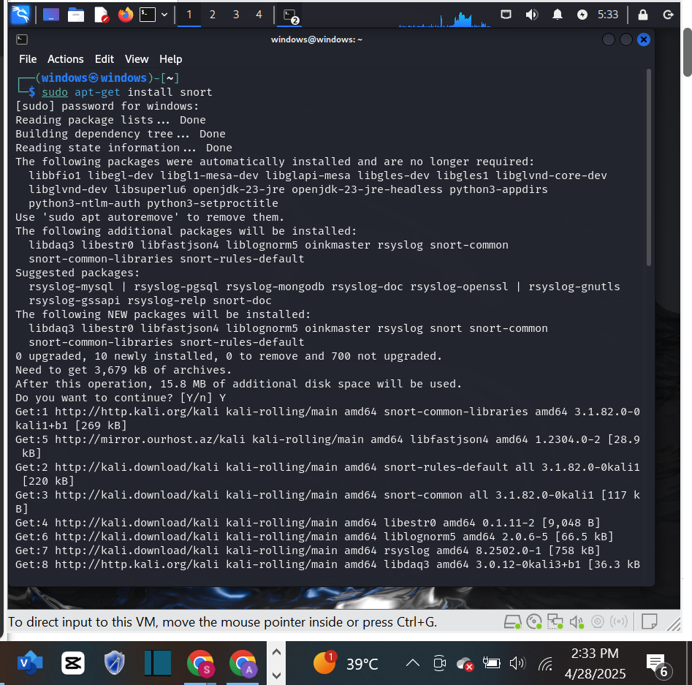

**Configuring and starting snort:**

**2- Locate HOME_NET and modify it to your local network.:**

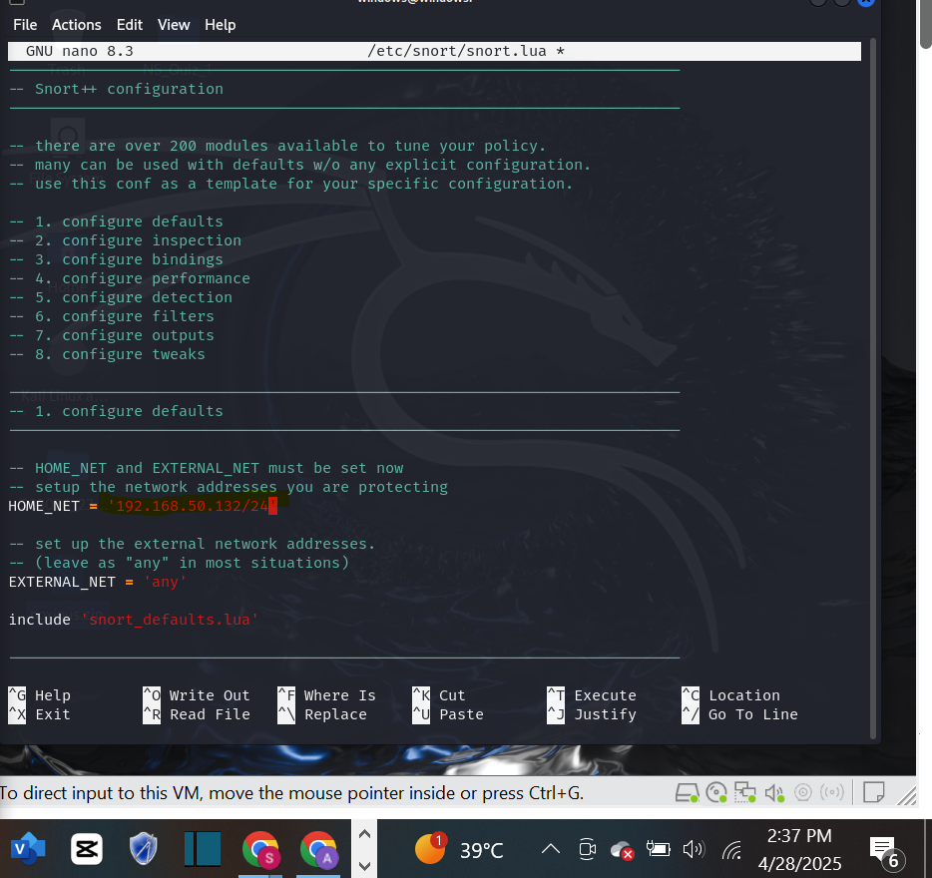

**3- Validate your configuration file.**

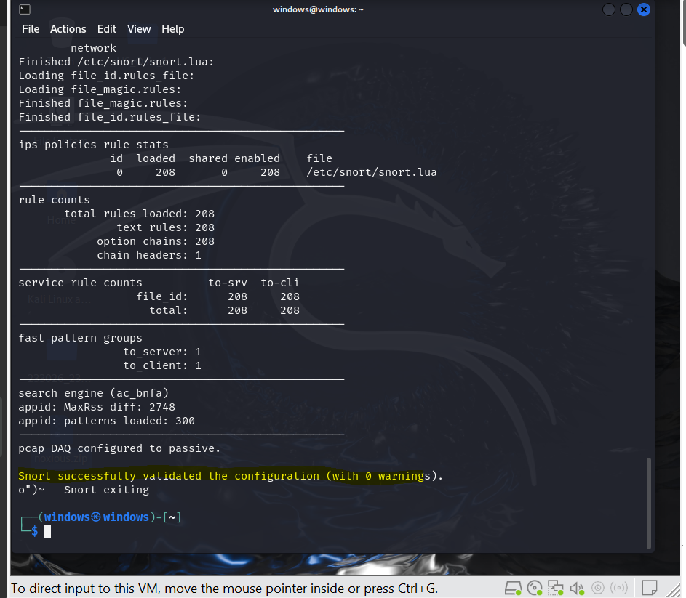

**5- Open local rules file to add your snort rules.**

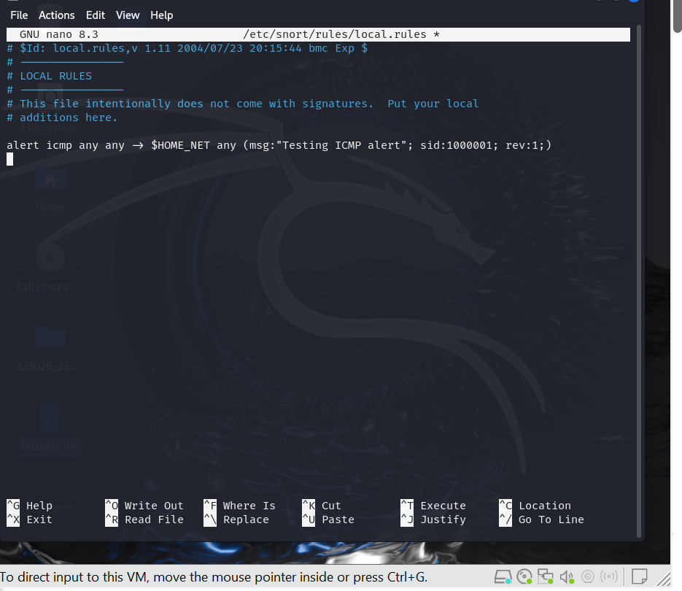

**2. Write and add another snort rule and show me you trigger it.**

**a. The rule you added (from the rules file)**

**b. A description of how you triggered the alert**

**Question No. 2: Write a rule that will fire when you browse to snort.org from the machine Snort**

**is running on; it should look for any outbound TCP request to snort.org and alert on it.**

